- Project Planning & Management
- • Project Proposal –
Car rental management system
The Car Rental Project is a platform that connects car owners who want to rent out their vehicles with customers looking to rent a car. The project aims to help car owners benefit from their unused vehicles by earning extra income, while also providing customers with an affordable and convenient transportation option for a specific period without the need to buy a car.
In this way, the project creates a mutually beneficial solution, enabling owners to make use of their cars and allowing customers to easily rent a vehicle at a reasonable price to meet their daily or personal needs.

• Project Plan :
Timeline (Gantt chart)
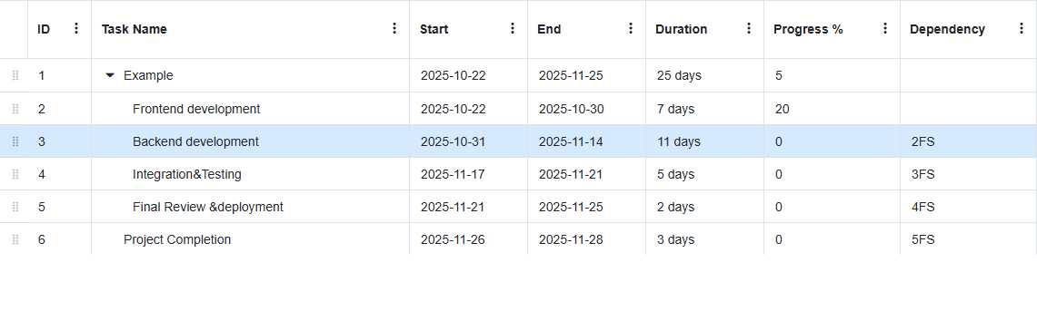
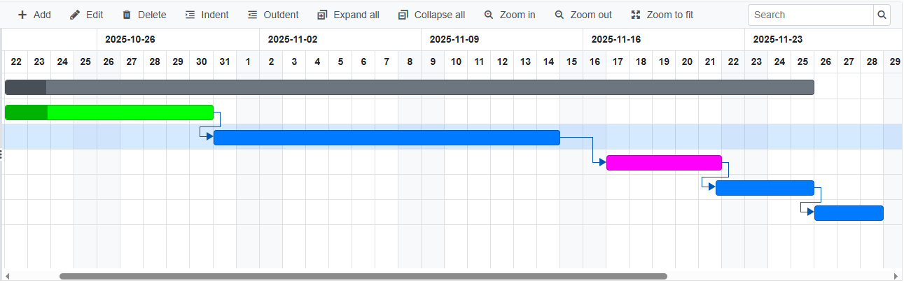
Milestones
Frontend development completion | 30-10-2025
Backend development completion | 14-11-2025
Integration &Testing completion | 21-11-2025
Final Review &Deployment completion | 25-11-2025
Project Completion | 28-11-2025
Deliverables:
Project documentation, Project presentation, Full project source code, Testing reports.
- • Risk Assessment & Mitigation Plan :
Risk | Impact | Solution Plan
Delay in task delivery by some team members | medium
  Create a clear timeline for each task + hold weekly follow-up meetings
 | high
  Errors may occur when connecting the frontend with the backend
  Conduct early testing using Postman
 | high
  Database connection issues
  Use a backup version of the database
Adding overly complex features | high
  Before implementing any new feature, it must be well analyzed and understood through reliable sources such as YouTube tutorials and official documentation. If the feature seems too complex, it should be simplified.

• KPIs
KPI
  Target Value
  Response Time
  ≤ 2 seconds
  System Uptime
  ≥ 99%
 | ≥ 95%
  Booking Success Rate
 | ≥ 85%
  Customer Satisfaction

Stakeholder Analysis – Identifying Key Stakeholders and Their Needs
1. Admin
The admin manages the entire system including users, cars, bookings, and payments.
Needs: Full access to manage data, generate reports, ensure system security, and monitor transactions efficiently.

2. Car Owner
The car owner lists their vehicles for rent on the platform.
Needs: A secure process to list cars, verify their identity, track rental history, and receive payments safely.

3. Customer (Renter)
The customer uses the platform to rent cars.
Needs: A simple registration and login process, easy car search and booking options, secure payment methods, and accurate rental information.

4. System (Platform)
The system acts as a bridge between car owners and renters.
Needs: To maintain data consistency, ensure information security, and provide smooth interaction between all users.

UI/UX Design- Screens and visual representations of the user interface. :
This is visualisation inspiration for our project:

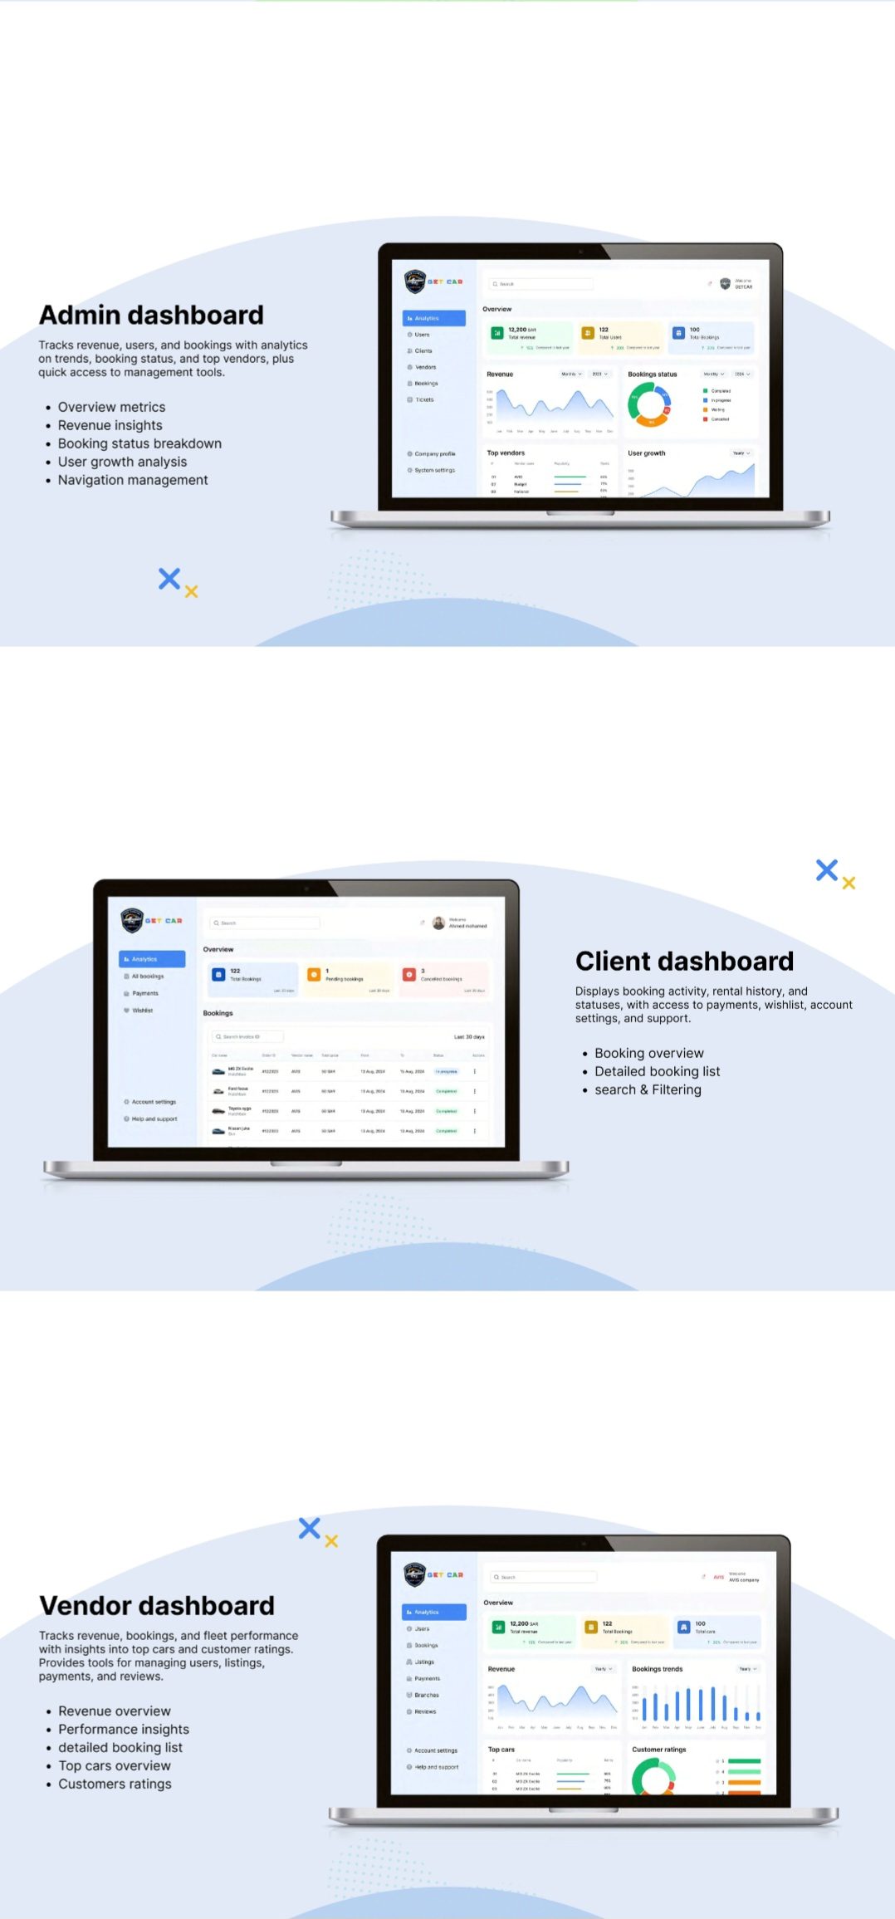
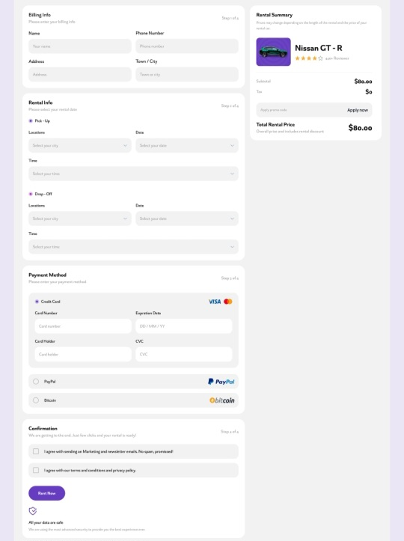
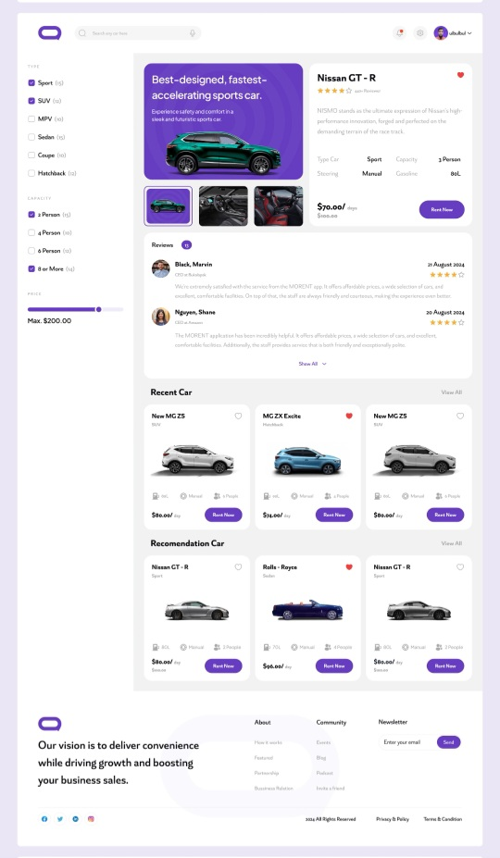

Database Design & Data Modeling:

https://github.com/AsmaaIbrahim-lab/Car-Rental-Management-System/blob/develop/Car_rental_management_system_ERD.drawio
Physical Schema:
https://github.com/AsmaaIbrahim-lab/Car-Rental-Management-System/blob/develop/Car_rental_management_system_Schema.drawio

